TEAM LEADER
- J THIRU VENKADAM

TEAM MEMBERS
- SURYA PRAKASH
- THIRU MALAI
- VIGNESH S

Creating Developer Account
Creating a developer org in salesforce.
1. Go to developers.salesforce.com/
2. Click on sign up.
3. On the sign up form, enter the following details :
a. First name & Last name
a. Email
b. Role : Developer
c. Company : College Name
d. County : India
e. Postal Code : pin code
f. Username : should be a combination of your name and company
This need not be an actual email id, you can give anything in the format :

Custom objects:
1.Semester
2.Candidate
3.Course Details
4.Lecturer Details
5.Internal results

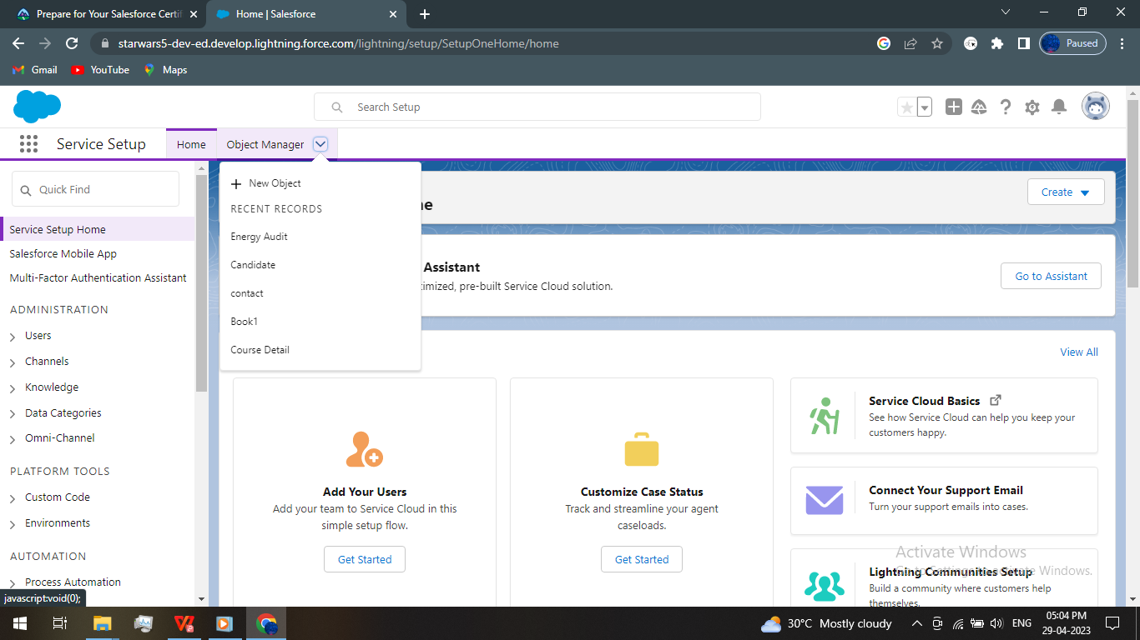

# The field and relationships are deployed by the given TABLE

#An object relationship in Salesforce is a two-way association between two objects.
Relationships are created by creating custom relationship fields on an object.
#they can also see and access related data.

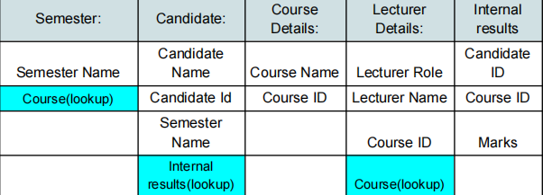

TABS
- Each Object are added with a tab style and labeled by their object names so that they can be visible in the app launcher and app manager tabs

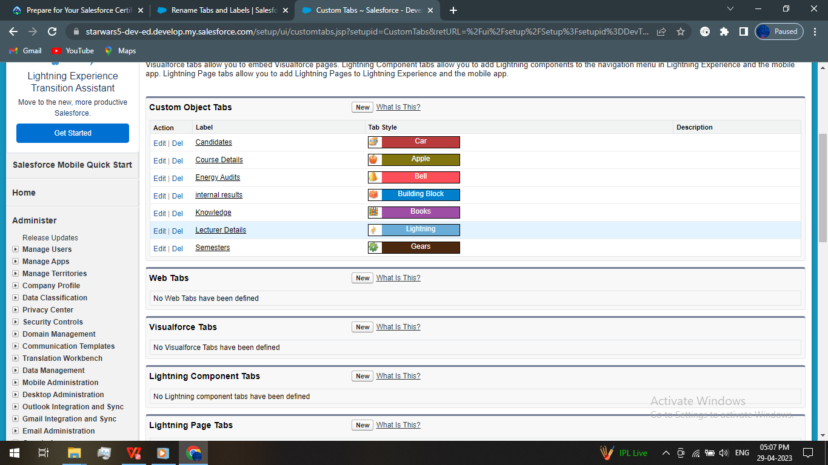

Milestone-3:Lightning App
- Apps in Salesforce are a group of tabs that help the application function by working together as a unit.
- It has a name, a logo, and a particular set of tabs. The simplest app usually has just two tabs.
Activity-1:
Create the Candidate Internal Result Card app:

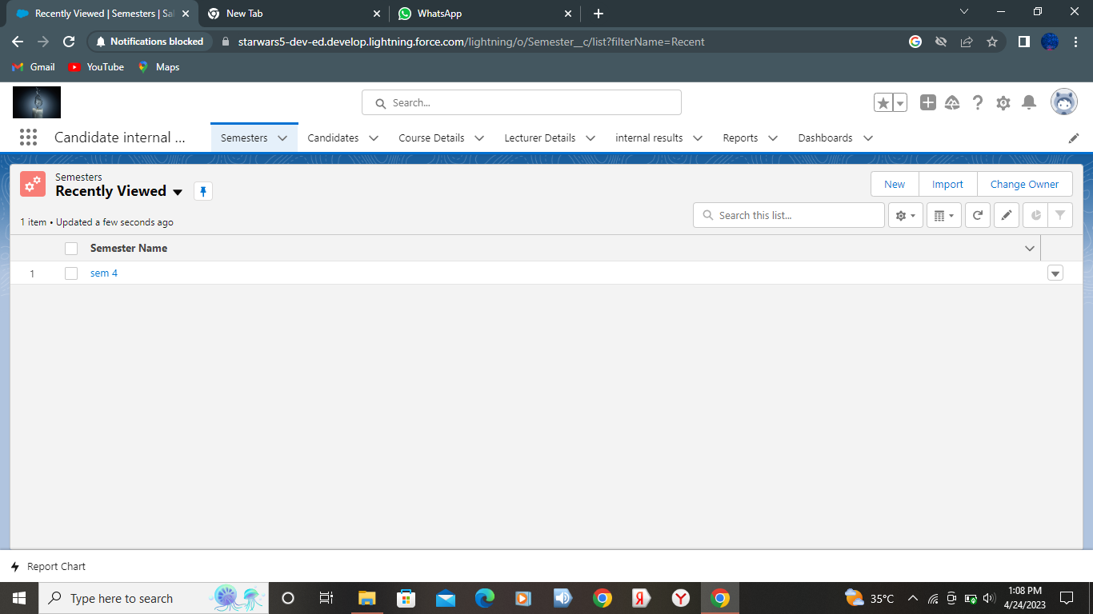

Milestone-4: Users
A user is anyone who logs in to Salesforce. Users are employees at your company,
such as sales reps, managers, and IT specialists, who need access to the
company's records. Every user in Salesforce has a user account.
Activity 1:
Creating a Users:
1. From Setup, in the Quick Find box, enter Users, and then select Users.
2. Click New User.
3. Enter the user’s name John Martin and (Your) email address and a unique
username in the form of an email address. By default, the username is the
same as the email address.
4. Select a Role(none)
5. Select a User Licence As salesforce.
6. Select a profile as Salesforce User.
7. Check Generate new password and notify the user immediately to have the
user’s login name and a temporary password emailed to your email

Milestone-5:Reports
A report is a list of records that meet the criteria you define. It's displayed in Salesforce in
rows and columns, and can be filtered, grouped, or displayed in a graphical chart. Every
report is stored in a folder. Folders can be public, hidden, or shared, and can be set to
read-only or read/write.

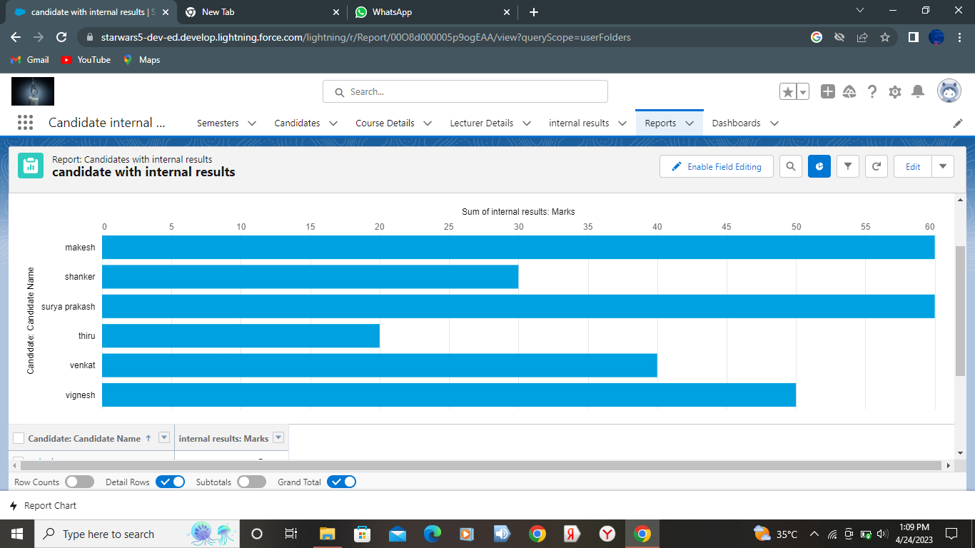

Milestone-6:Dashboards:
Dashboards let you curate data from reports using charts, tables, and metrics.
If your colleagues need more information, then they're able to view your
dashboard's data-supplying reports. Dashboard filters make it easy for users
to apply different data perspectives to a single dashboard.

